**ER in D365 FO**

Import Microsoft model, to ER

For importing Microsoft model, format and model mapping first of all go to LCS

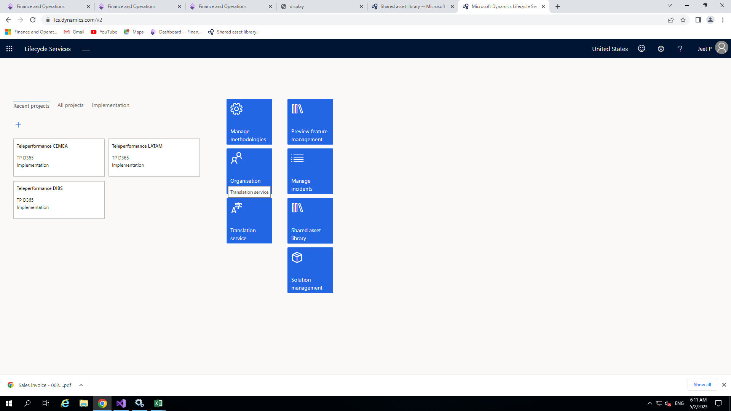

* 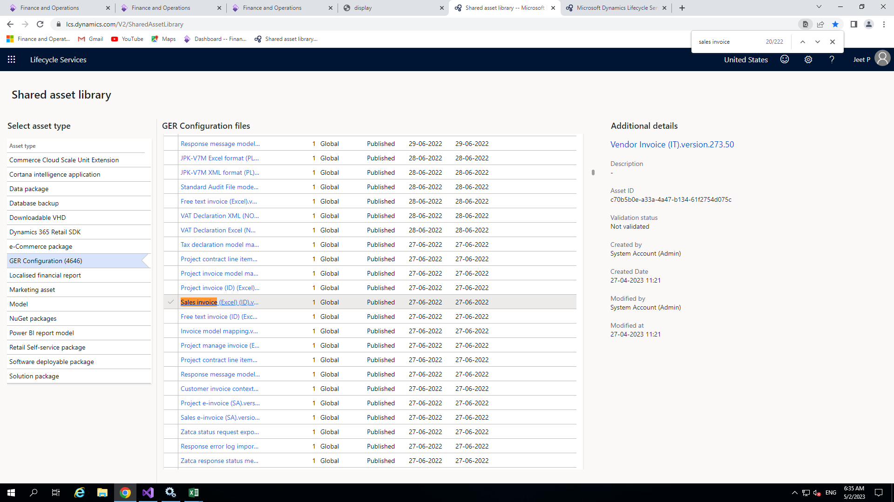After that go to shared asset library -> GER Configuration and search for sales invoice(Excel) template of appropriate version
* Just simply click on sales invoice report and the appropriate xml file will downloaded

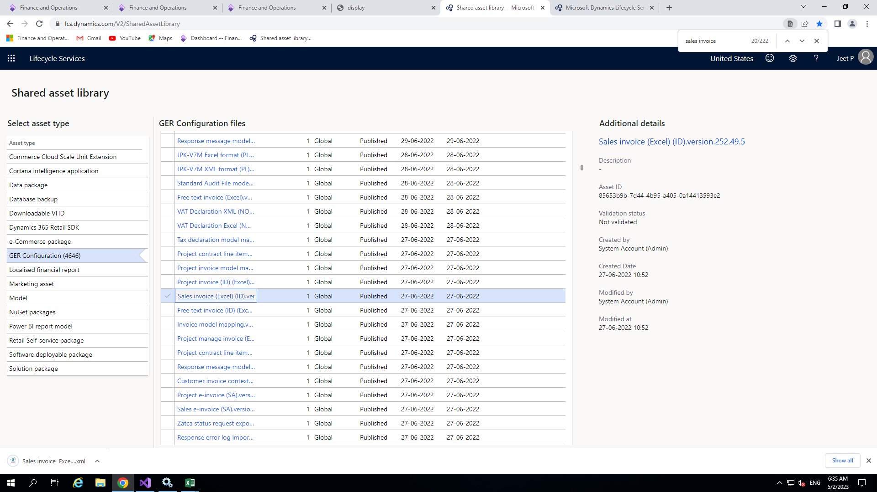

* Now open workspace in D365 F&O front end then workspace -> Electronic Reporting

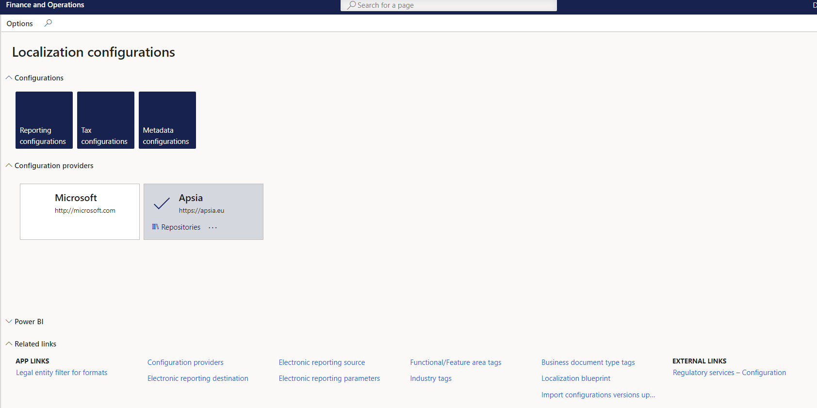

Now for creating new configuration providers

# Go to **Workspace > Electronic reporting. And then click on Configuration providers**

Add the name of new provider and the HTTP address.

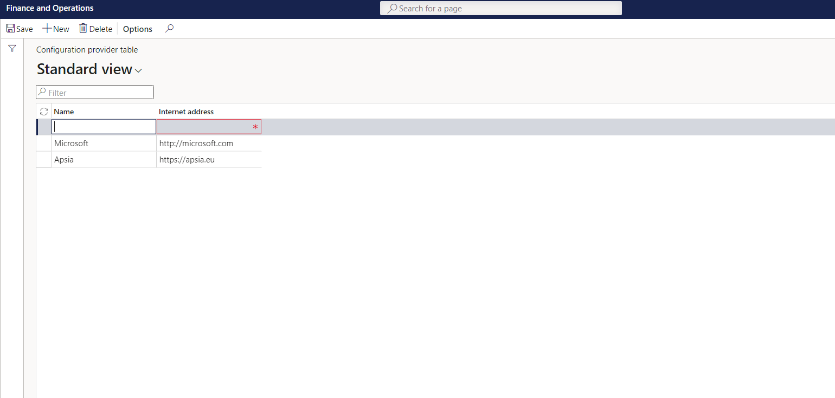

* Now click on configuration provider other than Microsoft and click on reporting configuration

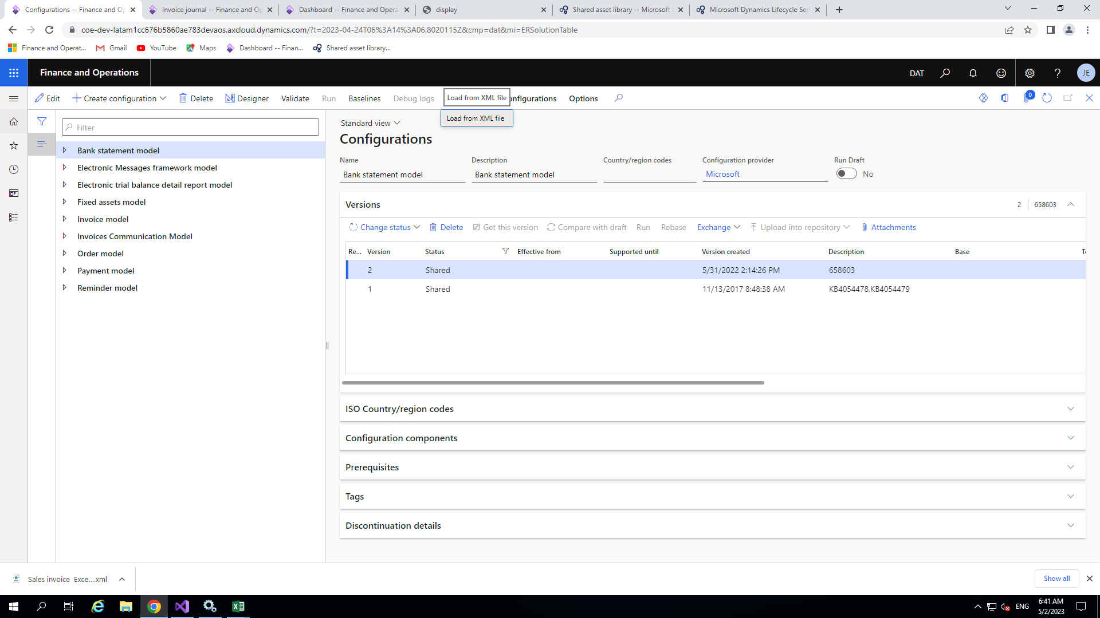

* Now click on exchange and load from XML and choose the downloaded file for (model,model mapping and format)

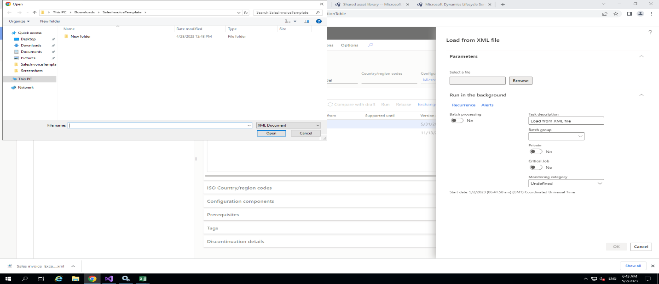

After importing all the files click on the model and click on the create configuration button to add the extension of the model

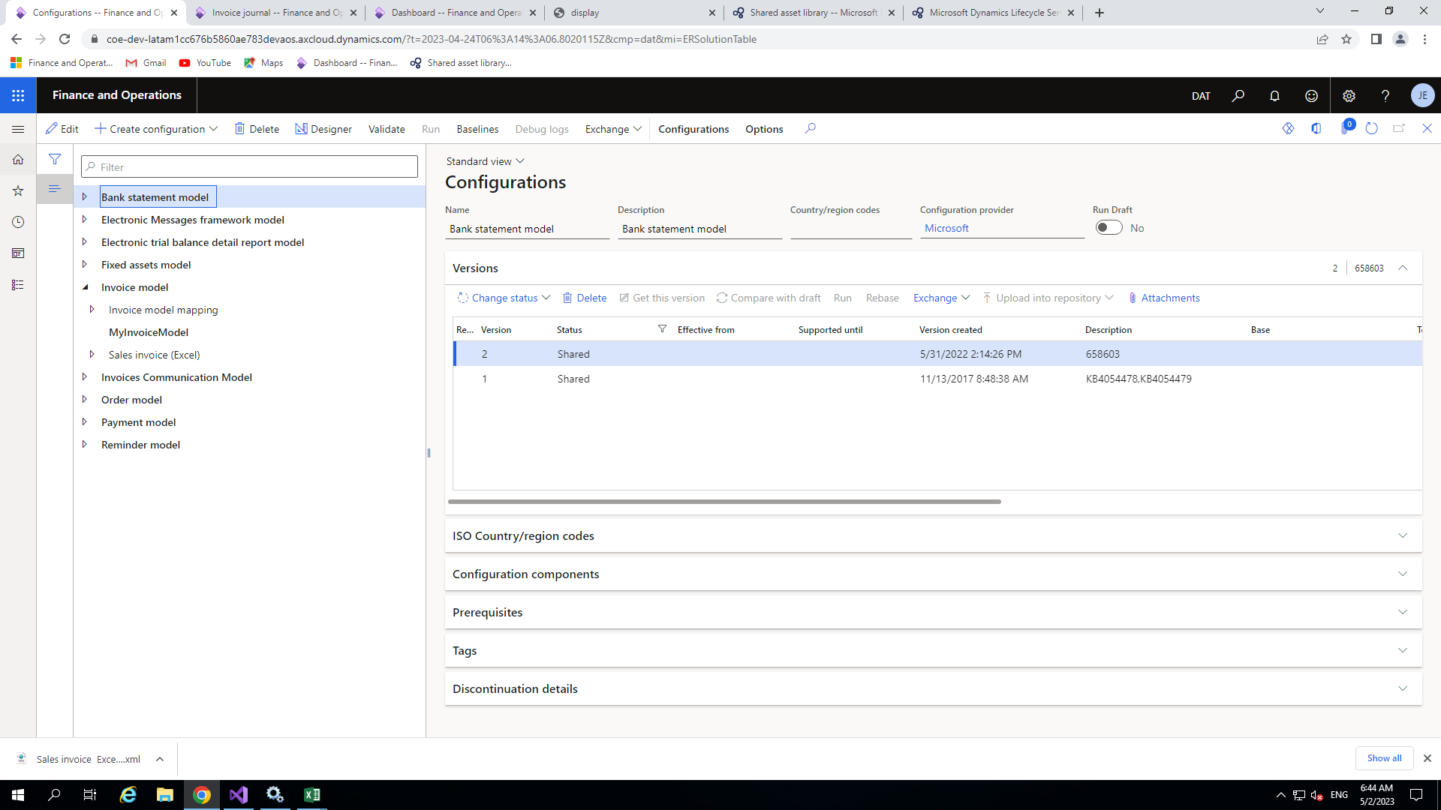

**What is Data model?**

A data model is the key element in an Electronic Reporting Configuration, providing the structure for the data sources to be bound to via a model mapping and providing the source for format configurations to have the output elements bound to.

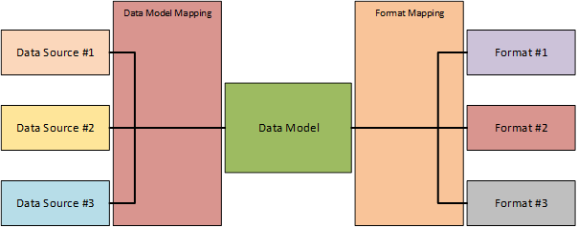

data model is the central structure to which you bind both the data sources and the output. We illustrated this with the image below.

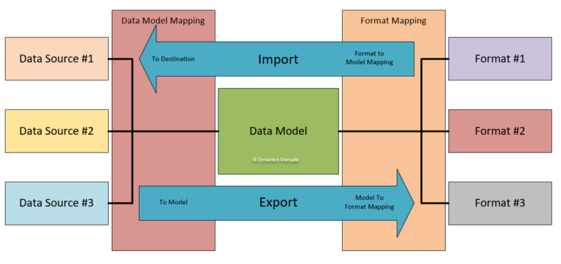

* Since Electronic Reporting can be used for both importing data and exporting data, the image above does not tell the full story. A model mapping can have two directions, To Destination which is used for importing data and To Model which is used for exporting data. The same goes for a format mapping, when exporting data, the mapping is performed directly in the designer and when importing data, the mapping is performed via the model mapping in the format mapping. The image below illustrates this.
* So now we will create one extension for that, click on main model and then click on create configuration

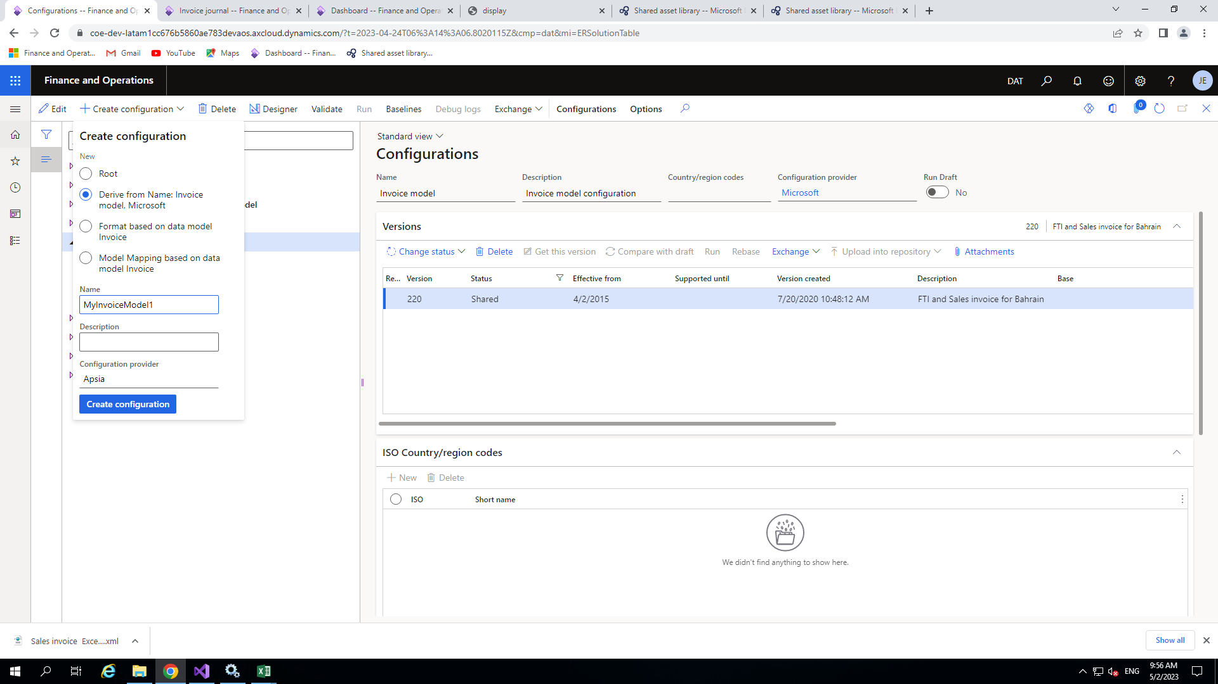

After adding new data model configuration click on that model and then click on designer

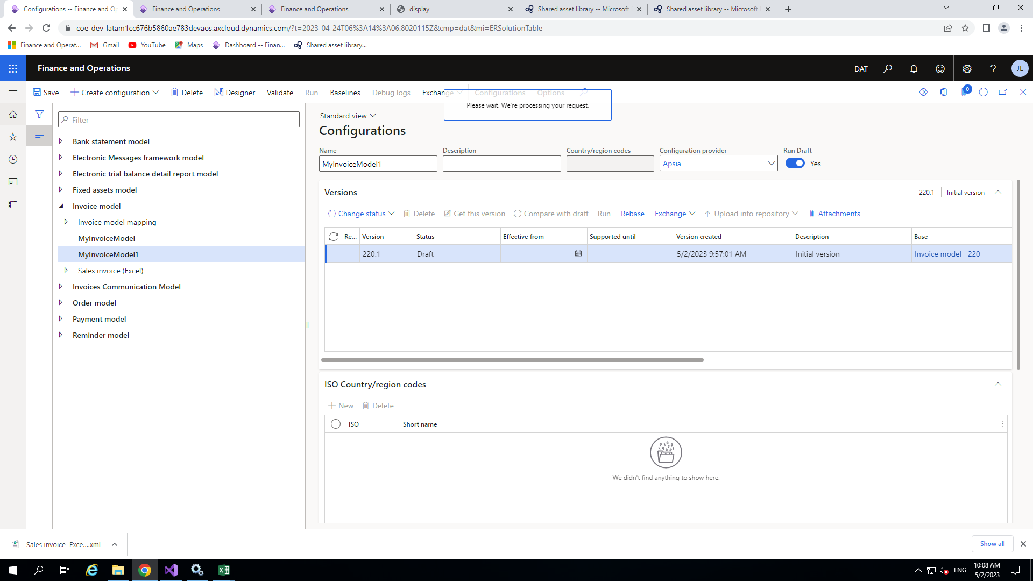

Now select the appropriate data source and click on new -> create node

* This is use for adding new field in existing report
* Here we are adding customer group name field in report which is not present in the template

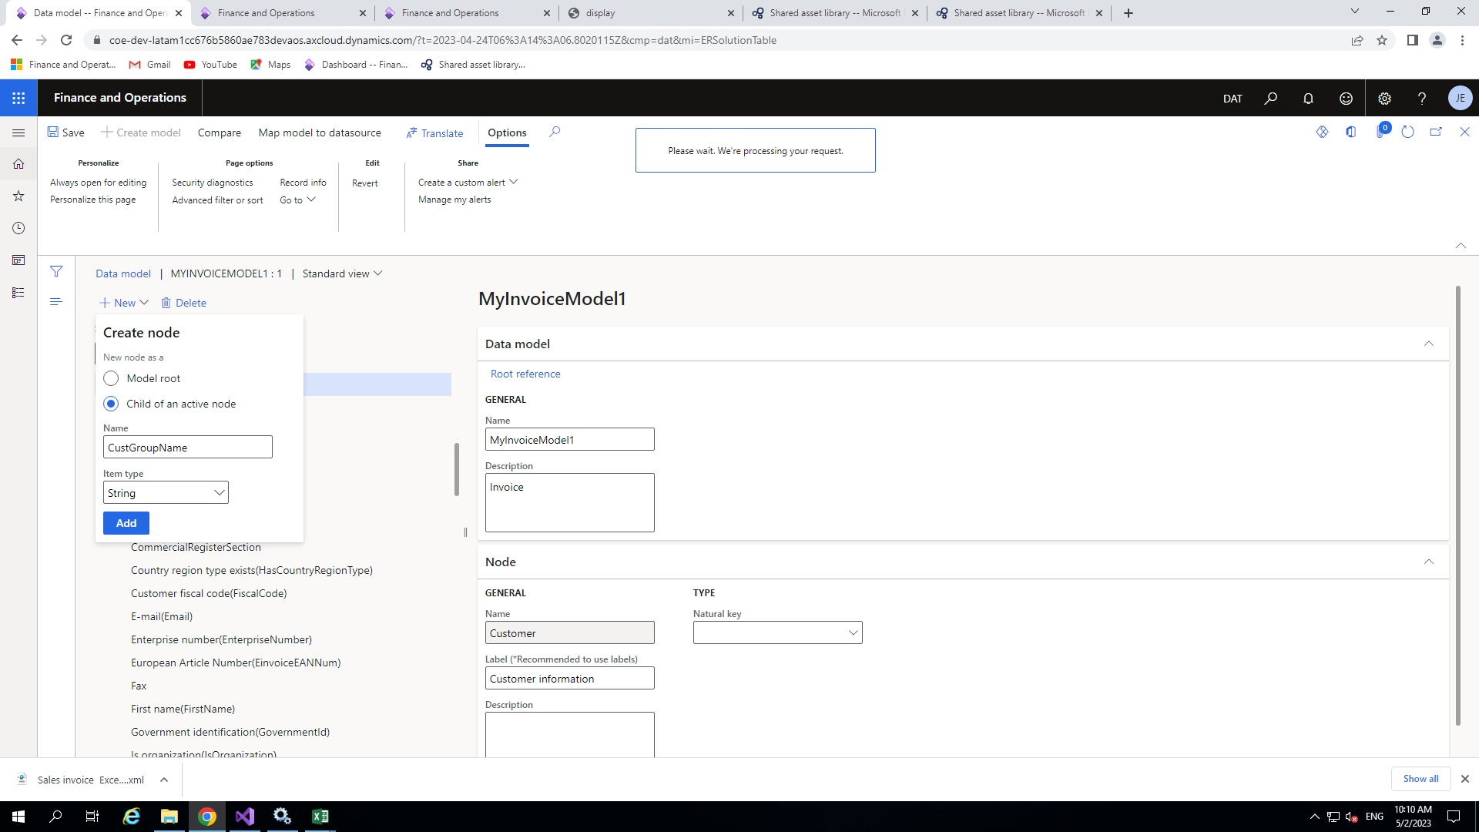

After adding the node our node looks like this

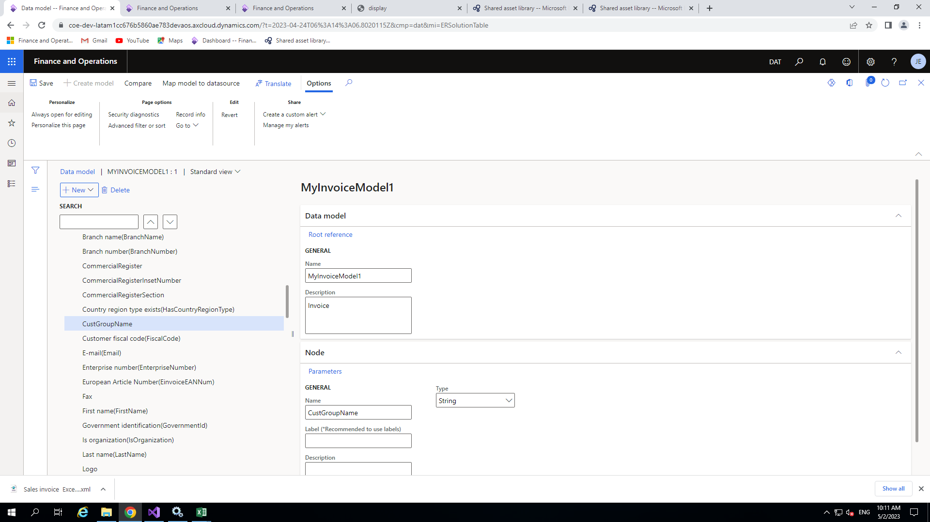

Now create model mapping by clicking on create configuration

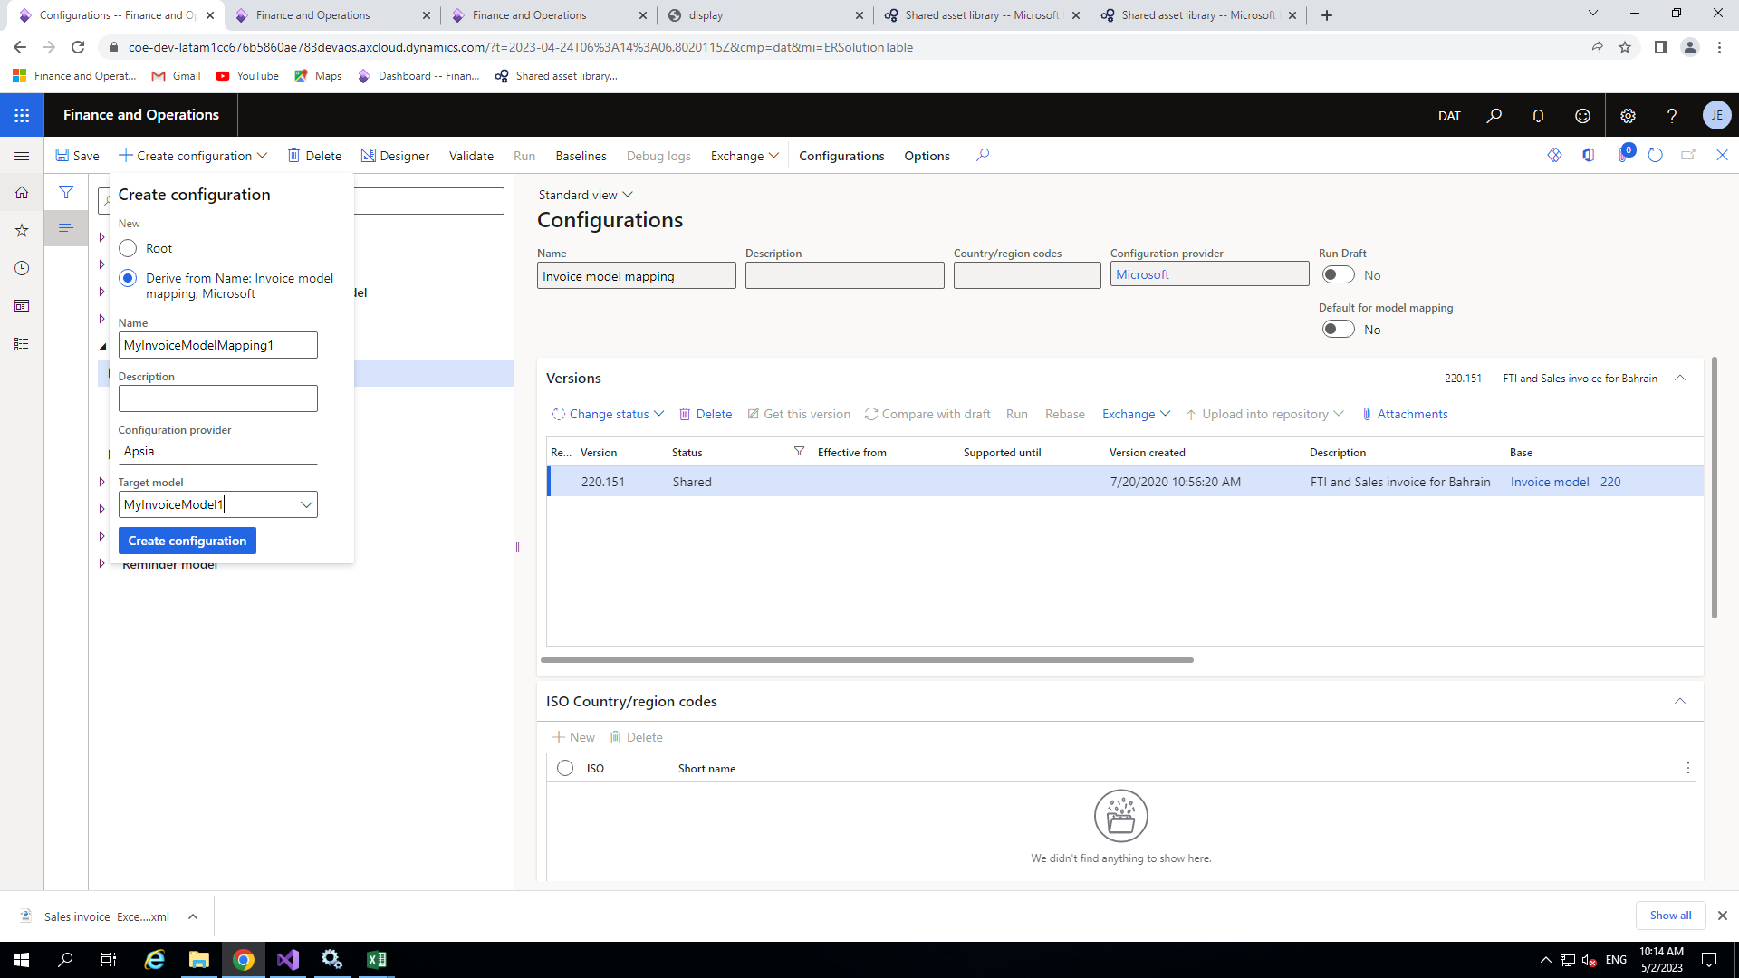

After adding model mapping enable field which is mentioned in the image below

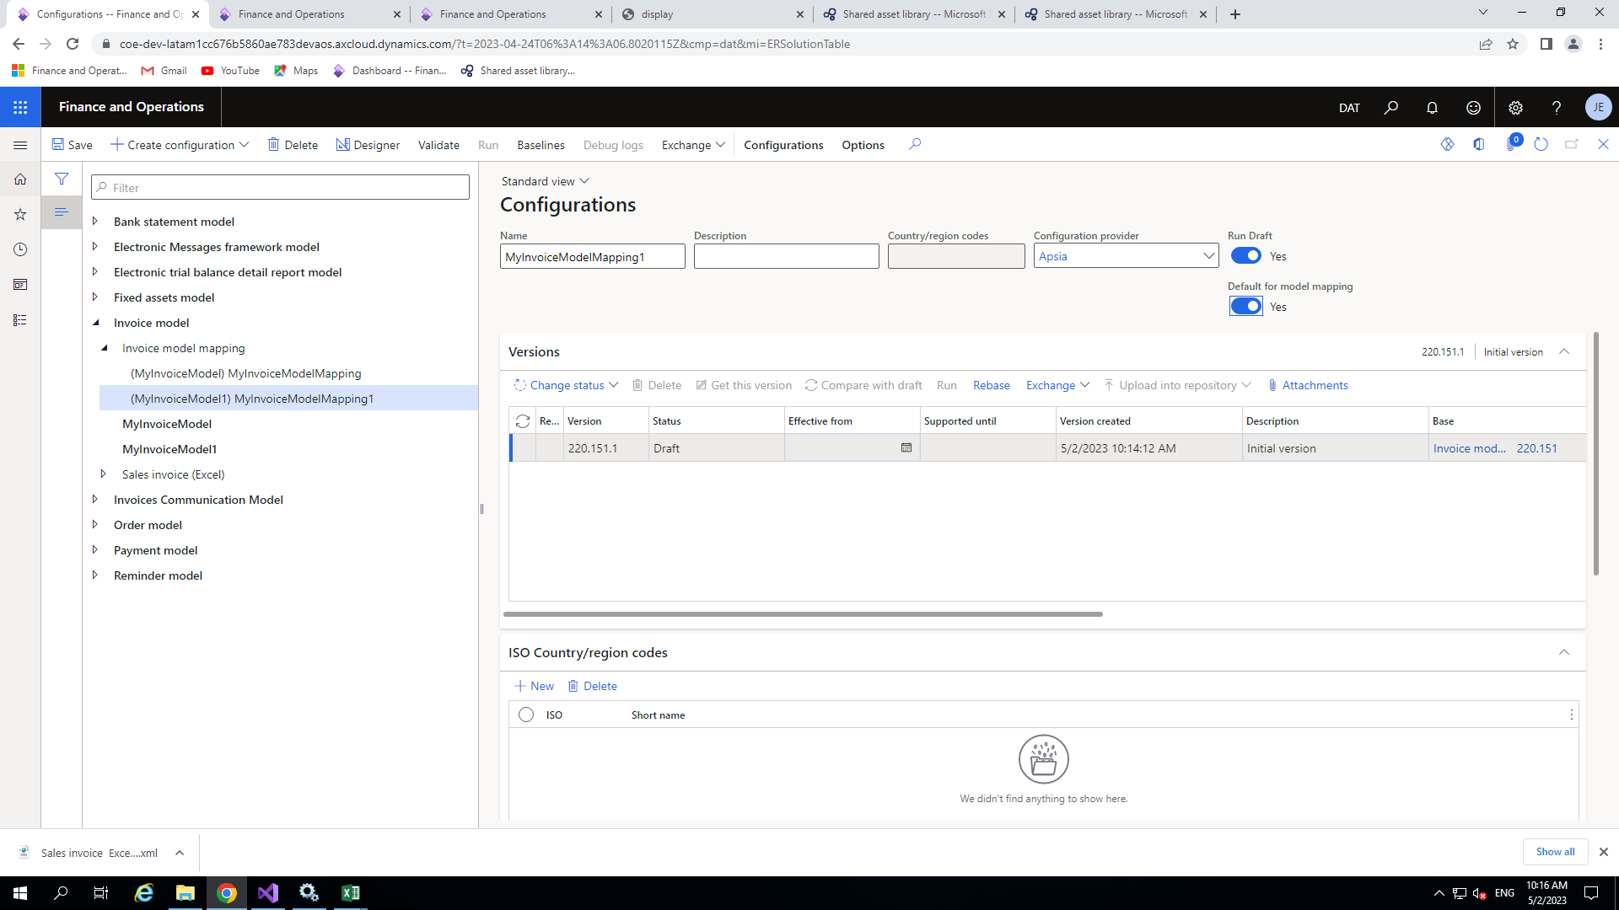

Now click on the model mapping and click on designer then click on salesInvoice(In my case) and then again on designer

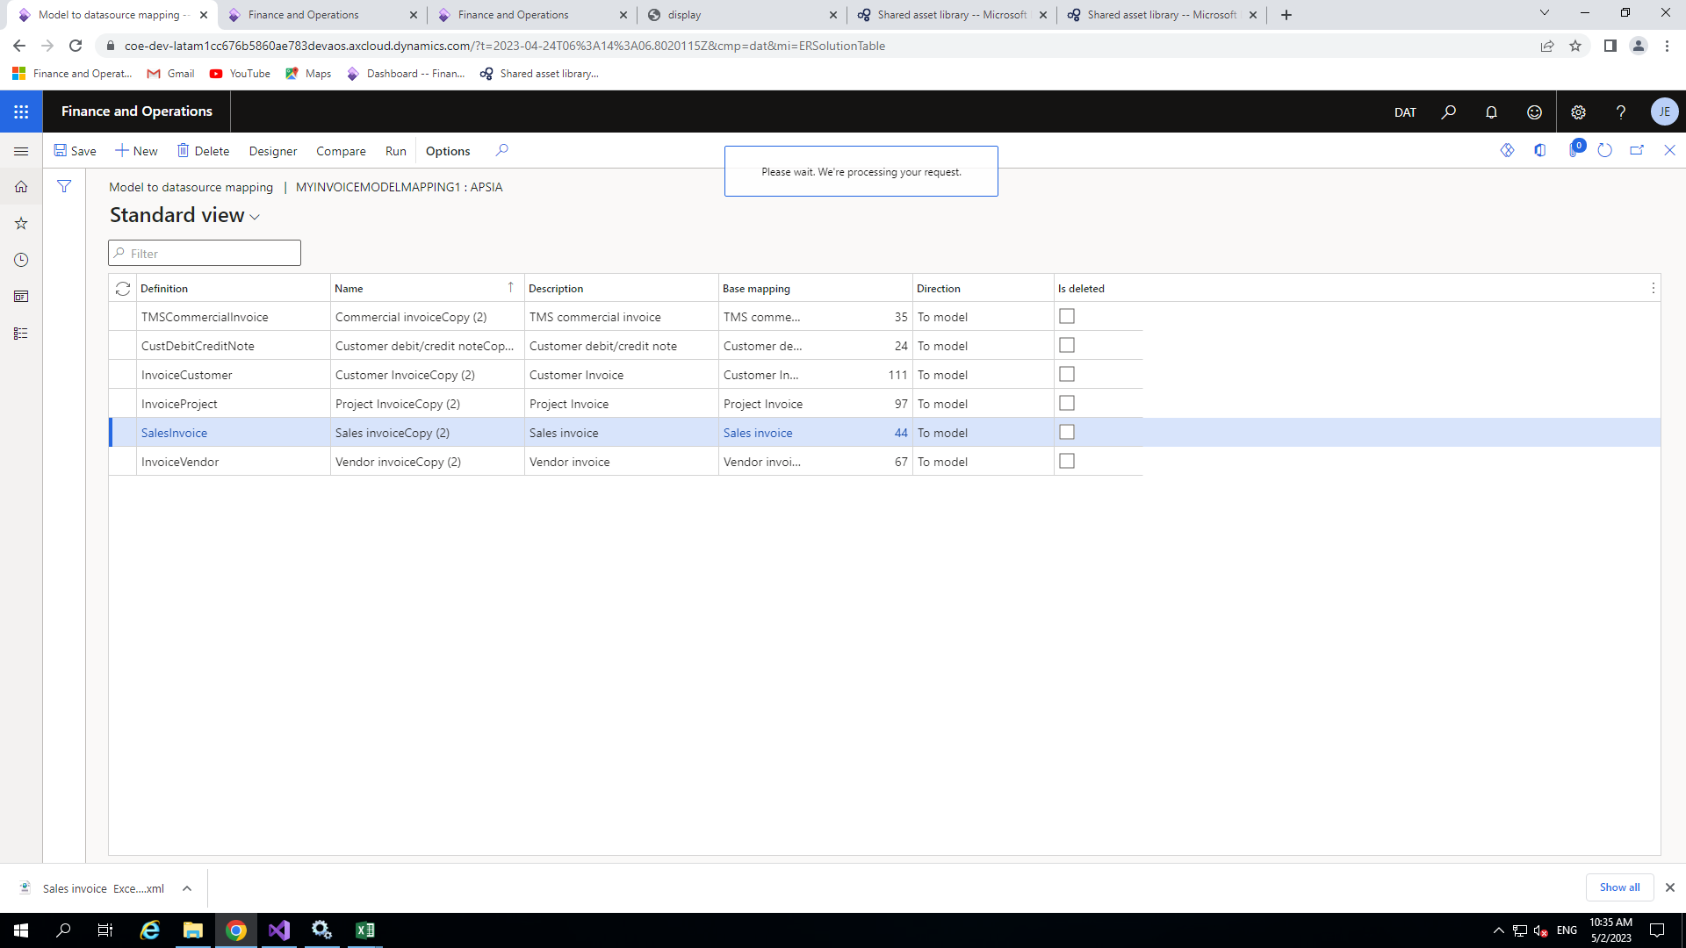

Here in below image we can able to see the data model at the right side and data source at the left side

* Click on the node which we have created before in the data model side
* And click on data source which data you would like to give to this data model node and just click on **bind.**

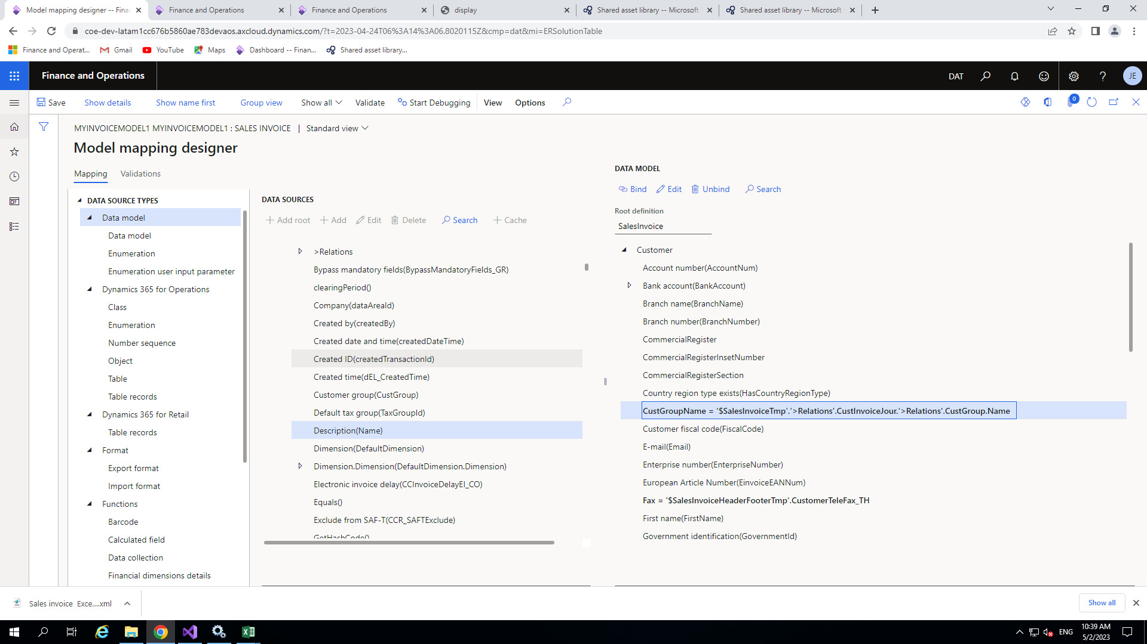

Now create the new configuration after clicking the format(in my case sales invoice)add fields like below

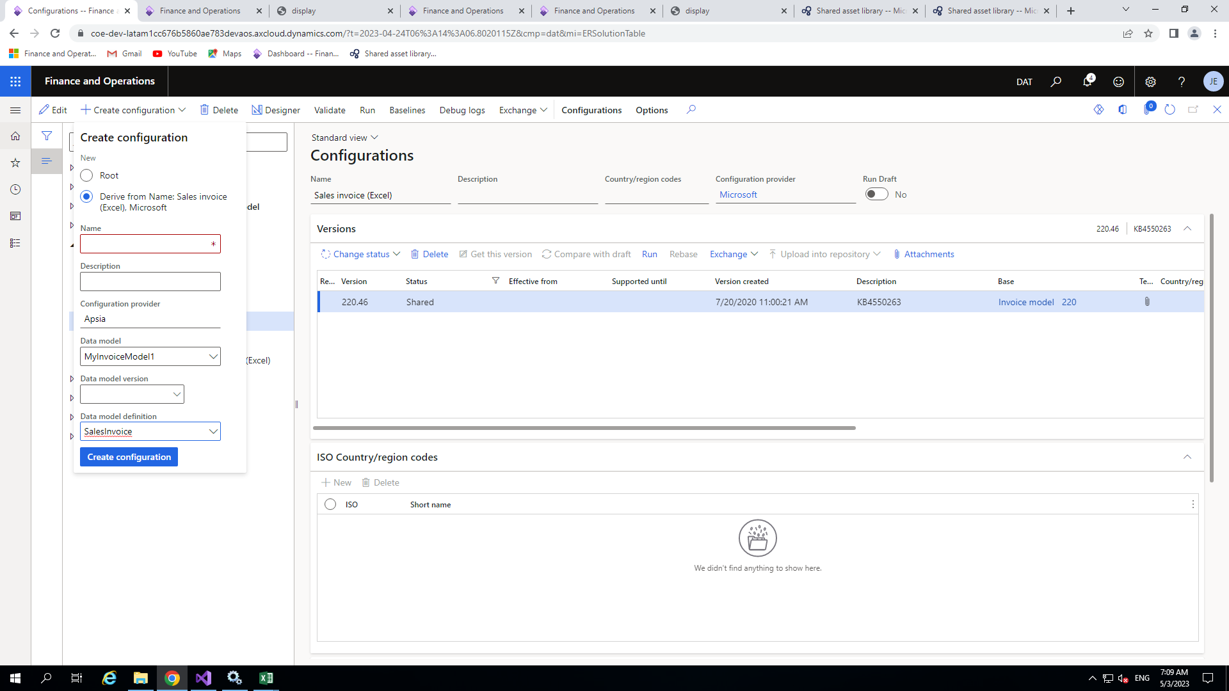

After that click on the configuration and then designer

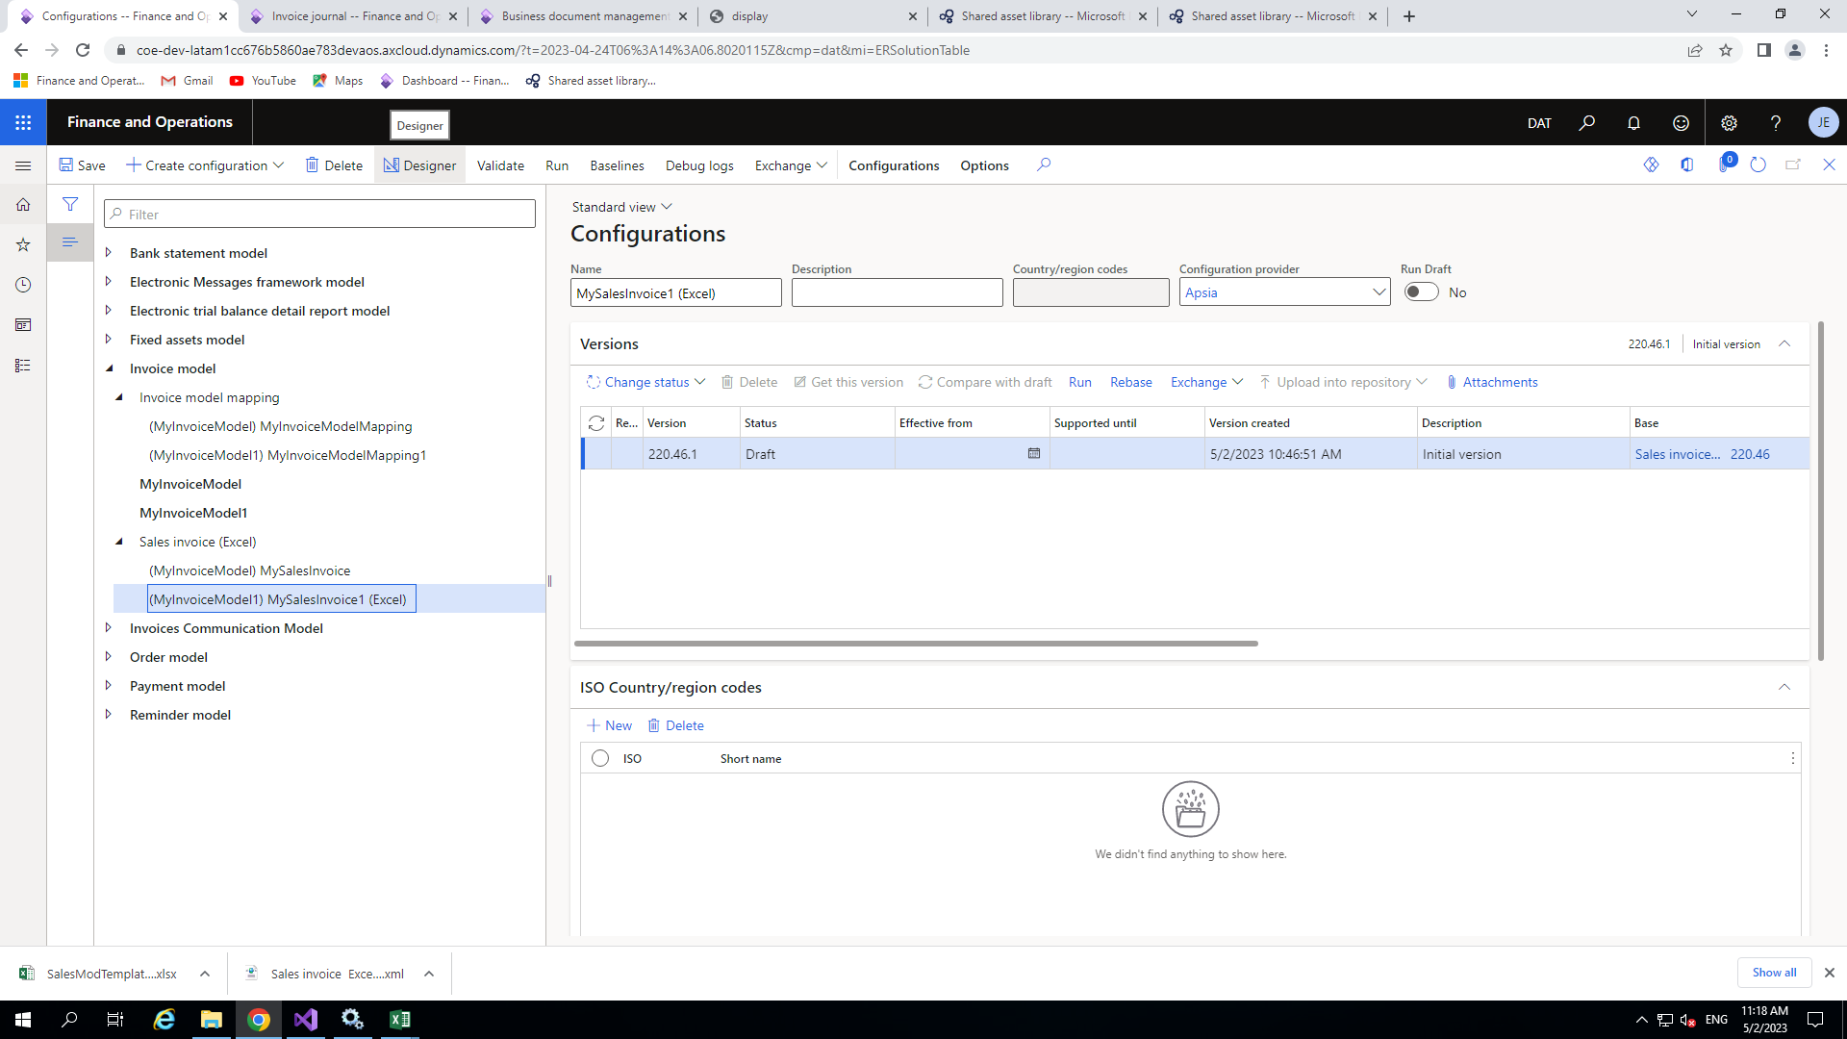

The next step is to import new template so just simply click on import and update from Excel

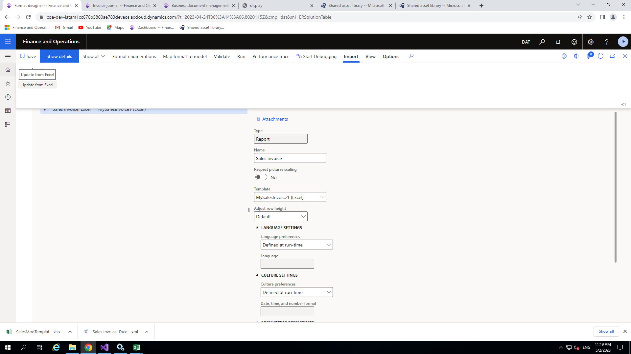

Here we have Update template button click on that select your new template with newly added fields (if you don’t have template go to attachments and simply download the excel by clicking the **open** button at the top and change it according to your convenience) and add that 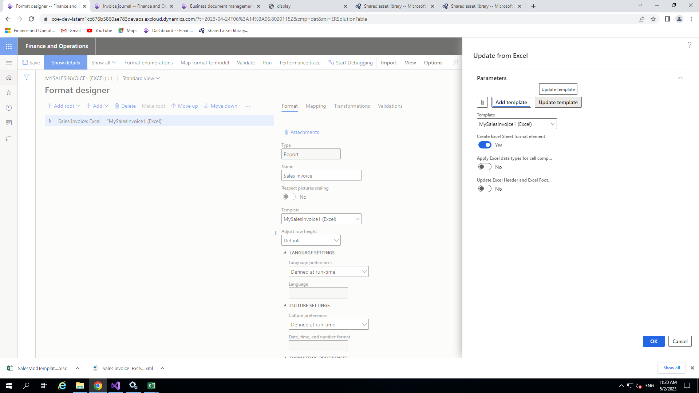

Now open **business document management** from front end and select the invoice which you imported and just click on edit button at right side below preview of the excel

* After that one dialog box is open just enter the version number and click **Ok .**

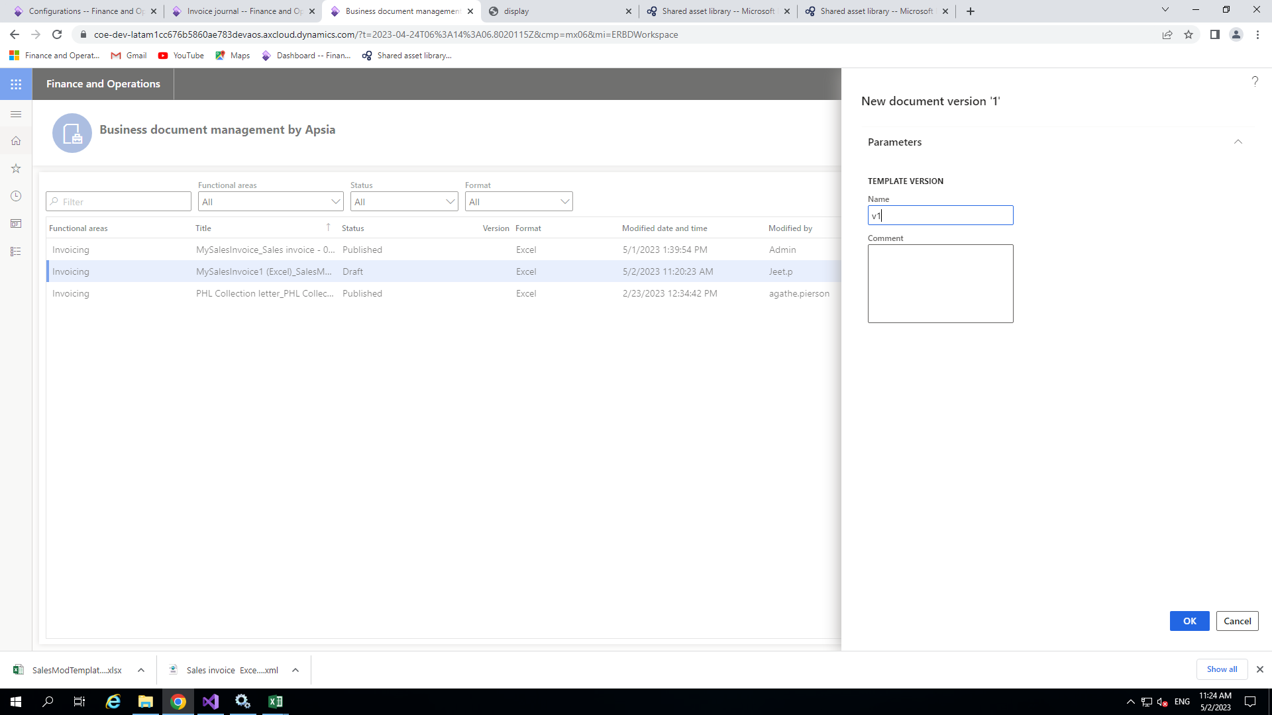

Once the excel file is open click on show structure

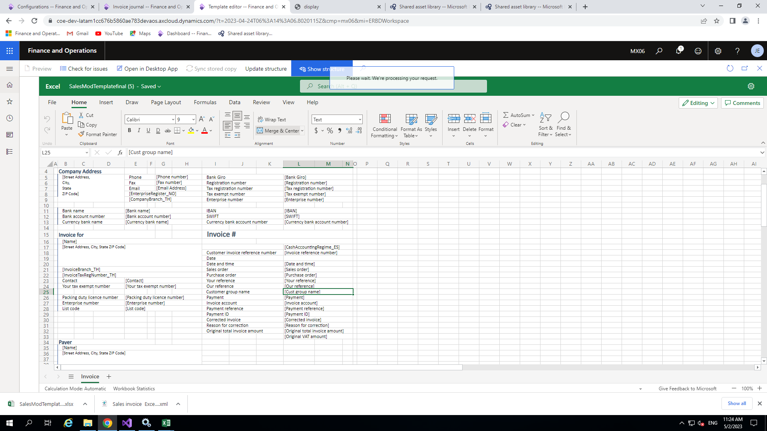

Once the dialog box is opened click on the cell from template which you want to put data and press add>cell make sure that the cell you have selected is proper then give the name of your field like other fields I have given the name “DocumentDetails_CustGroupName_Value” and click **Ok**.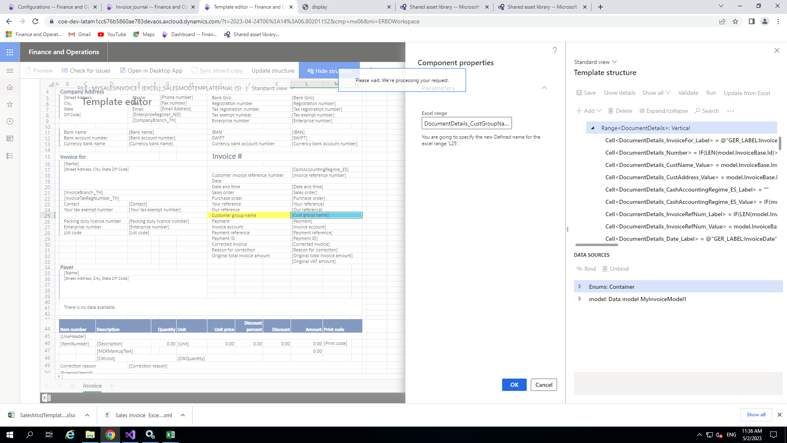

Now click on 3 dots and then show binding then click on the field which you want to bind and the cell we have created and just click on bind button

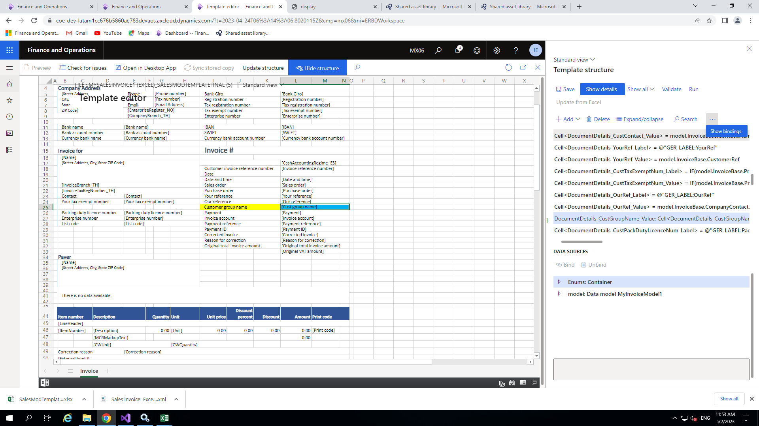

Now close this and click on the publish button as shown below

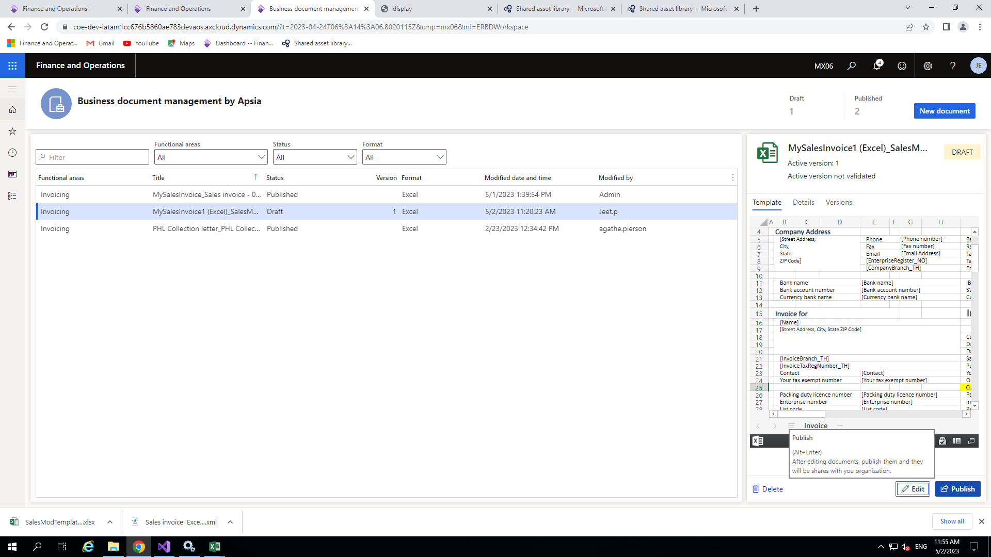

Now enable run draft button

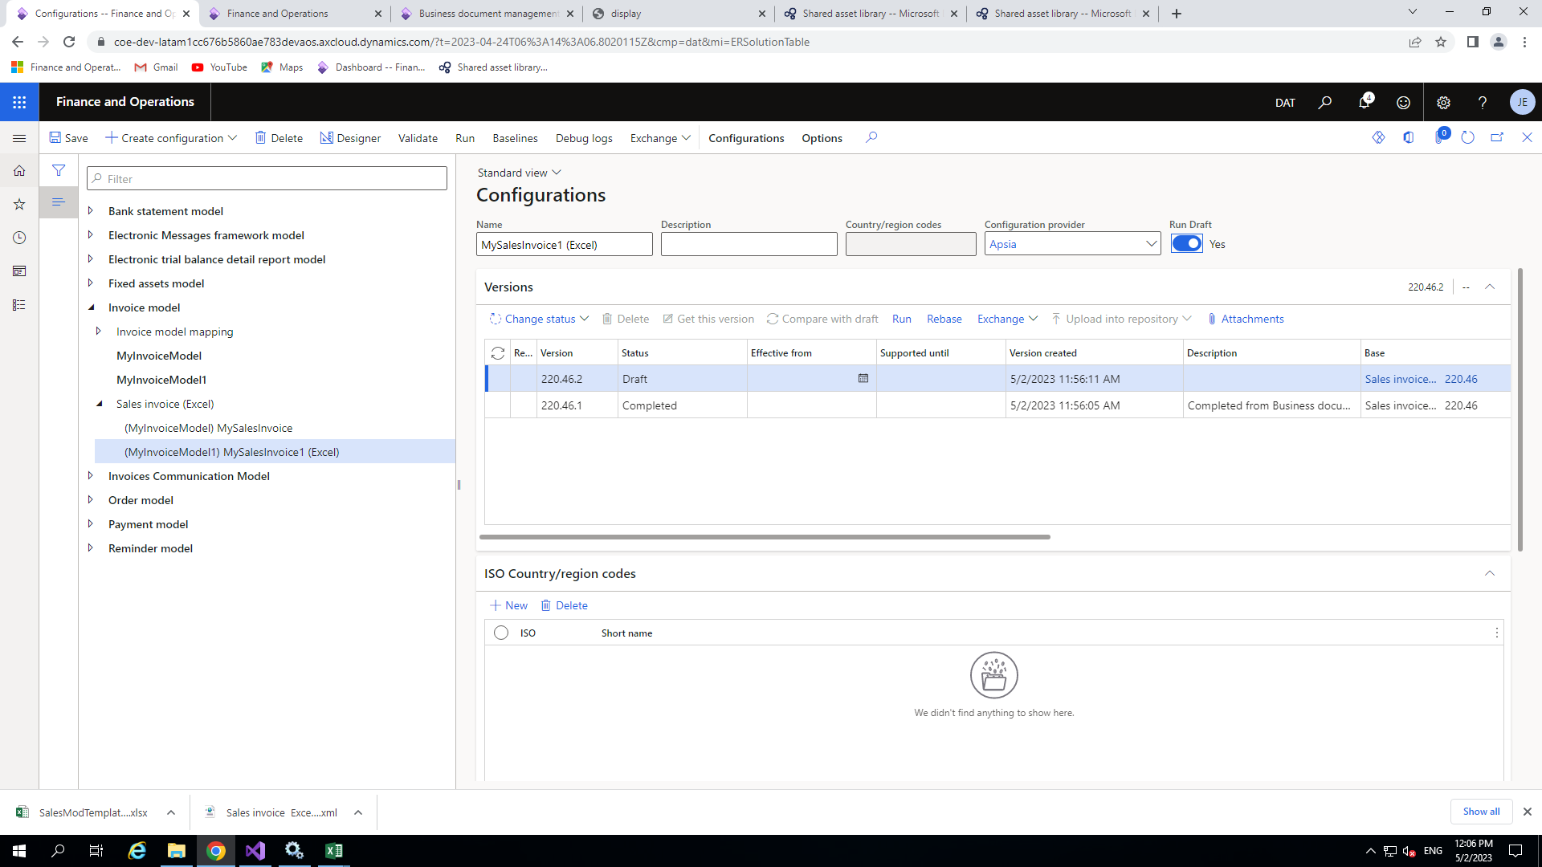

After that open form setup of the particular form(from where your report is opening)

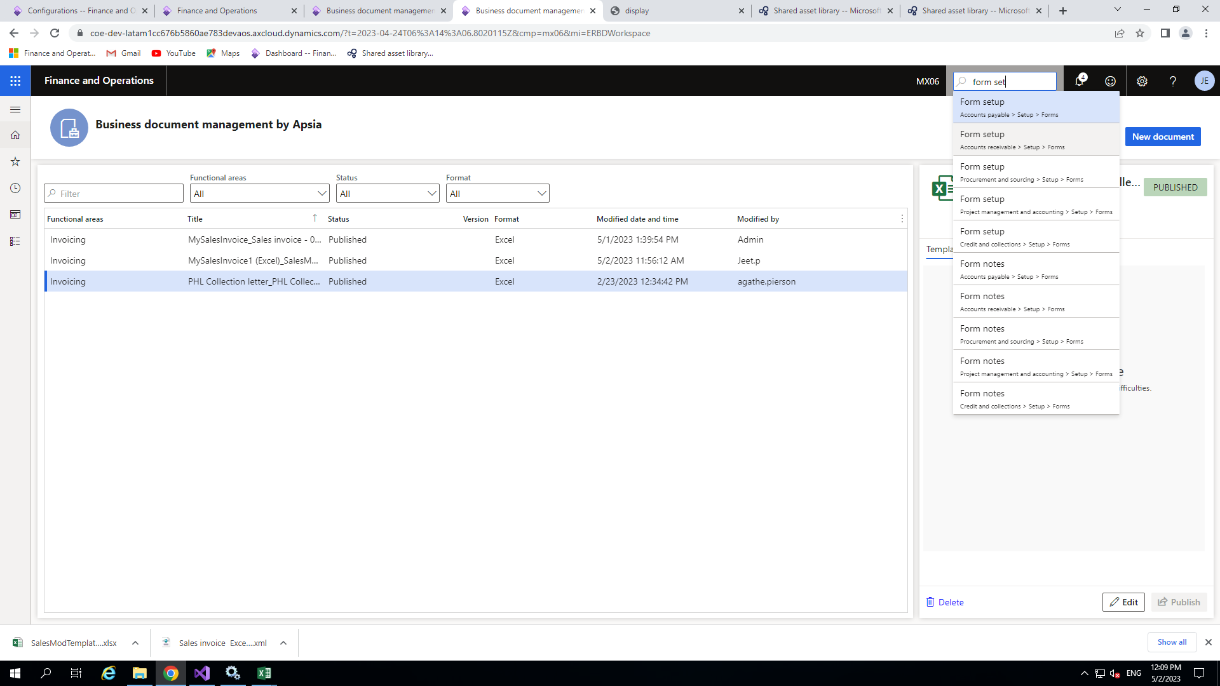

Now Go to print management

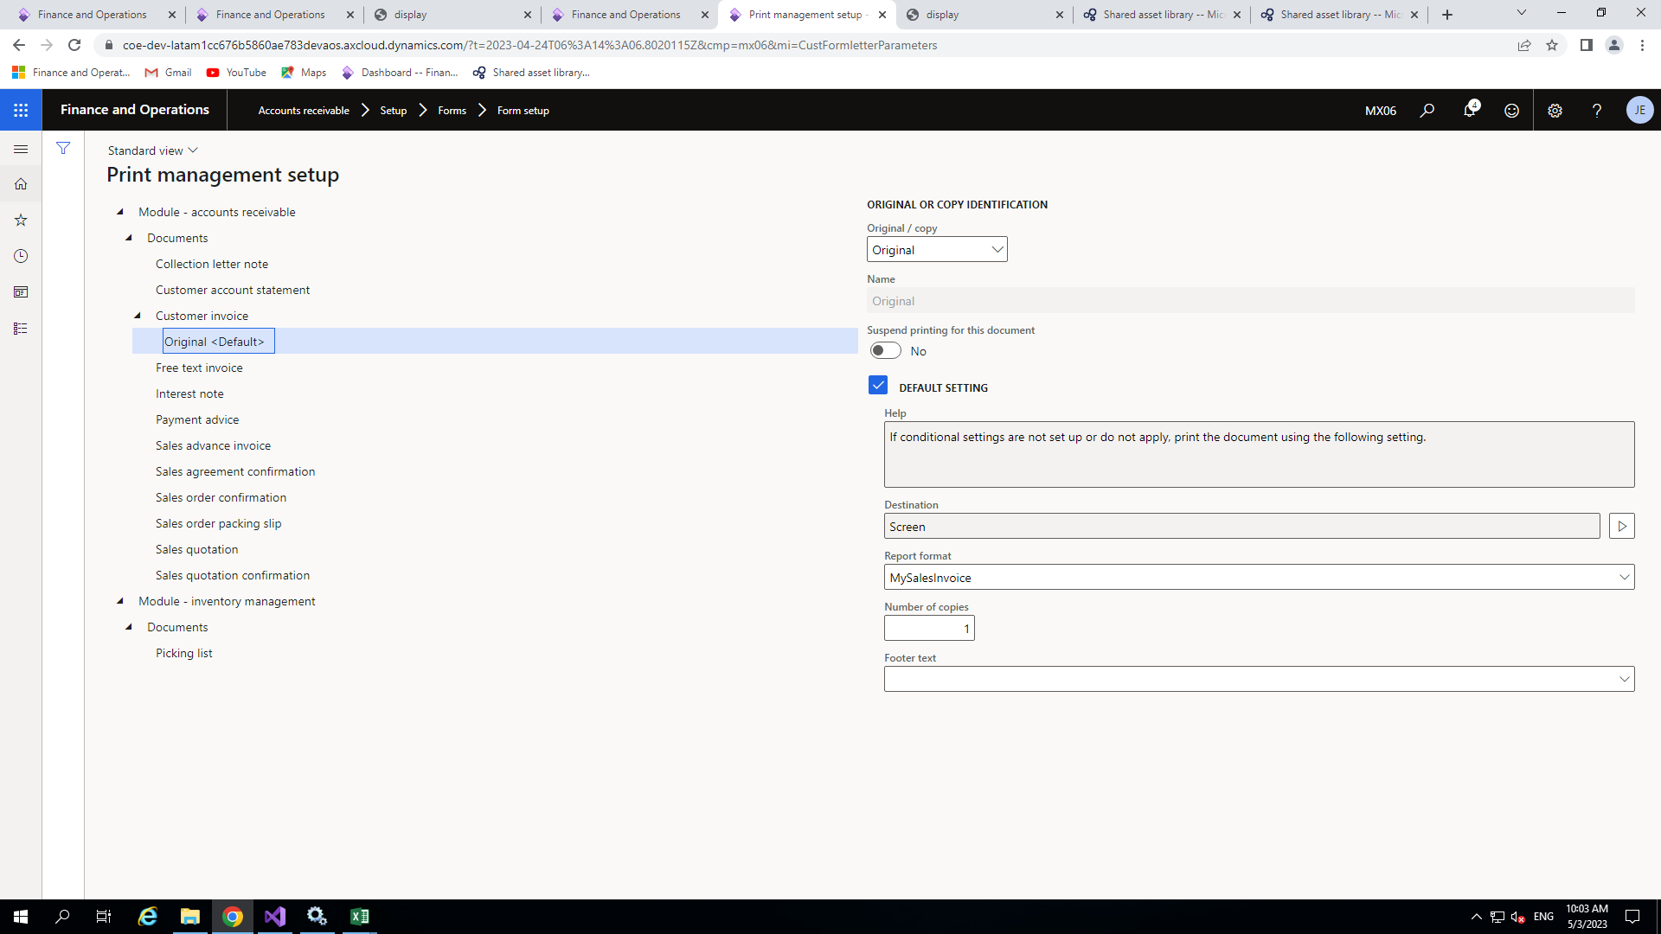

After that go to customer invoice and select the report format you had published

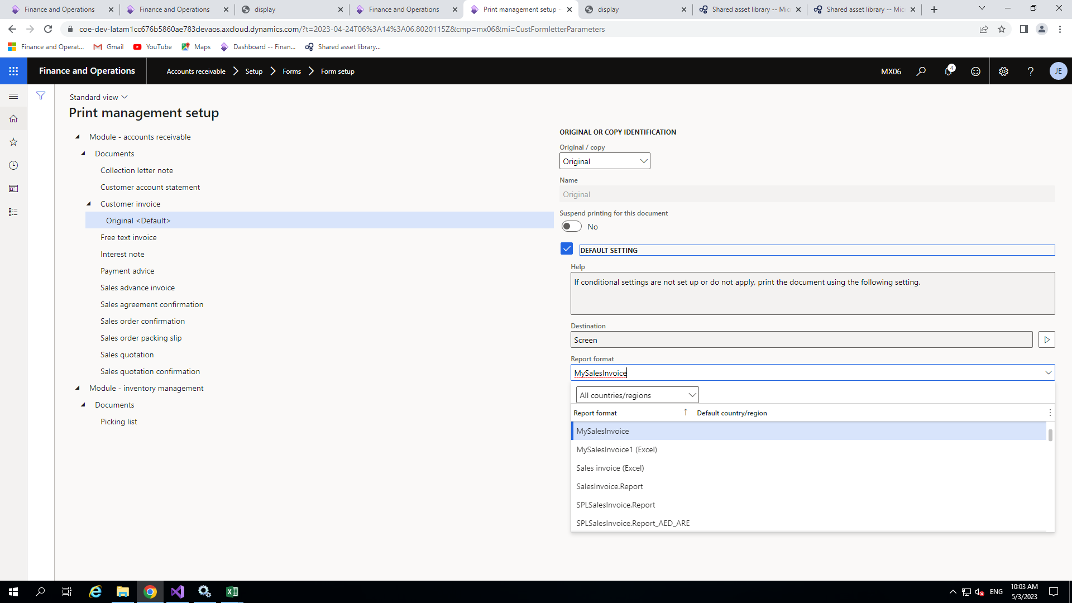

After clicking on the appropriate report you will get the output

